Kingdom of Saudi Arabia  Ministry of Education  Eastern Province Education Department  Tarbeat Al-Ajial International Schools |  |  |  |  |  |  | Date: ……/………/..………  Subject: Computer  Grade: G4
……………… |  | Seat Number |  | ……………………………………….. |  |  |  | Student’s Name
2nd Semester Exam (2nd Session) 2025/2026
Sign. | Consultative Name |  | Sign. |  | Corrector’s Name | Marks in letters |  |  | Marks  in numbers
 |  |  |  |  |  |  |  |  | 40
Question A: Write the correct name of each part.
After retouch | Before retouch | Canva
Impress | Keynote | PowerPoint









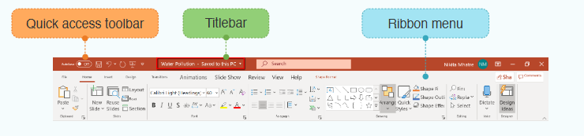
Question B: Write the correct name of each part
......................................
.......................
......................................
Quick access toolbar | Titlebar | Ribbon Menu

Question C: State whether ( True ) or ( False )

- Photo Retouching refers to making small changes in the image to improve its appearance.
  - True b. False

- Clone stamp tool allows to Fill, remove, or replace, certain areas with samples of other areas.
  - True b. False

- A manual sample is required for the Clone stamp tool.
  - True b. False

- Heal/Repair tool functions like the clone stamp tool, but with automatic source selection.
  - True b. False

- Heal/Repair tool functions like the clone stamp tool, but with automatic source selection.
  - True b. False
Good Luck

